

**National Park Service**

**U.S. Department of the Interior**

**Saguaro Douglas Fir (PSME) Plots QAQC and Analysis**

April 2024

Eva Deegan, SIP Intern

Windy Bunn, Fire Ecologist

Gabe DeJong, Fire Ecologist

National Park Service

Intermountain Region

## 

## **Summary**

## **Figures**

**Figure 1.** Douglas Fir plots seedling density over time by species and size class.

**Figure 2.** Douglas Firplots fuel loading (tons/acre) over time.

**Figure 3a.** Fuel loading (tons/acre) in Douglas Fir plots by size class adjusted to y scale.

**Figure** **3b.** Fuel loading (tons/acre in Douglas Fir plots by size class at a fixed y scale.

## **Appendices**

Appendix A:

## **Introduction and Objectives**

The following objectives were developed for the burn in 2001:

1. Reduce total fuel load by 30-50% one year post burn while maintaining total 1000hr fuels at 5-7 tons/acre
2. Reduce pole sized tree density by 30-50% two years post burn
3. Limit overstory tree mortality to ≤ 10% five years post burn
4. Increase herbaceous cover by 5-10% and increase diversity five years post burn

## **QAQC**

## **Seedlings Analysis and Discussion**

Figure 1. Douglas Fir plots seedling density over time by species and size class.

## **Fuel Loading Analysis and Discussion**

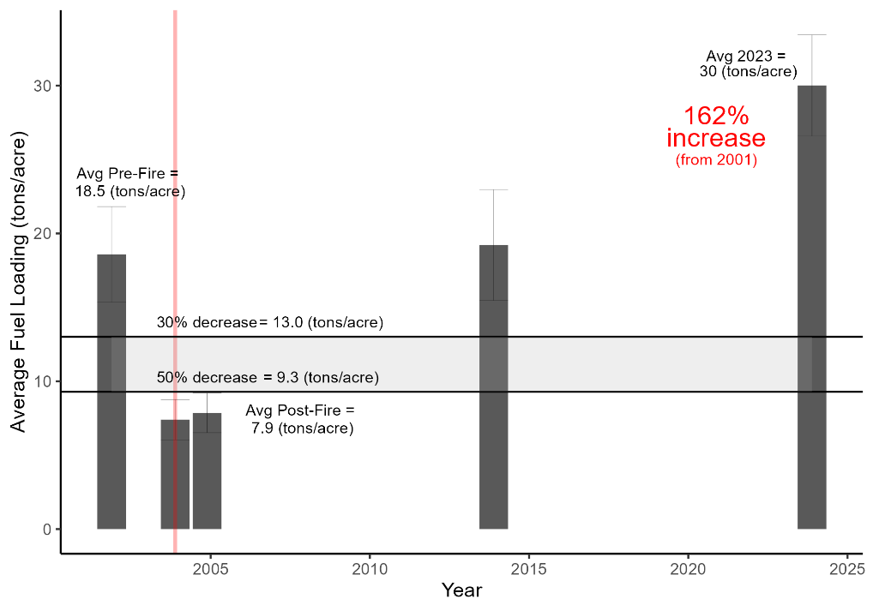

Figure 2. Douglas Fir plots fuel loading over time.

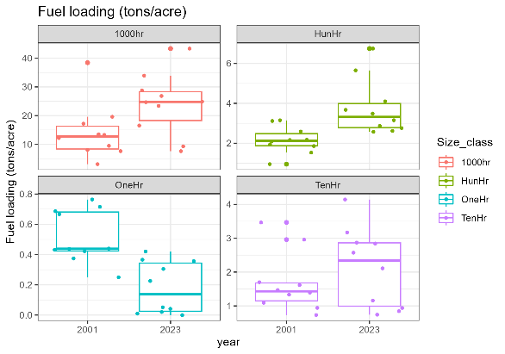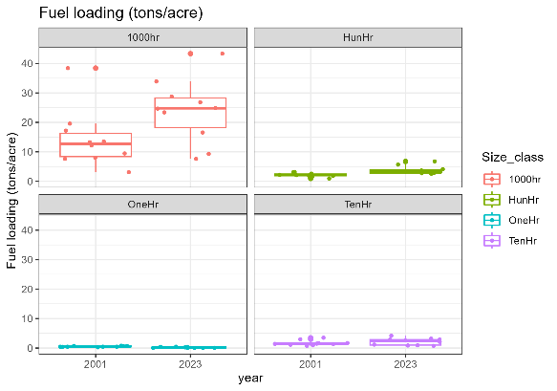

Figure 3a. Fuel loading (tons/acre) by size class adjusted to y scale.

Figure 3b. Fuel loading (tons/acre in Douglas Fir plots by size class at a fixed y scale.

## **Tree Analysis and Discussion**

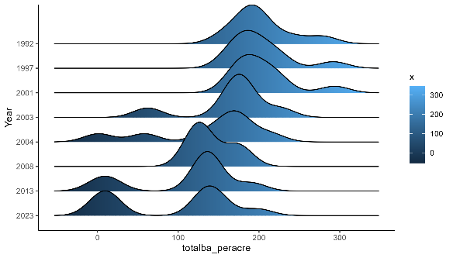

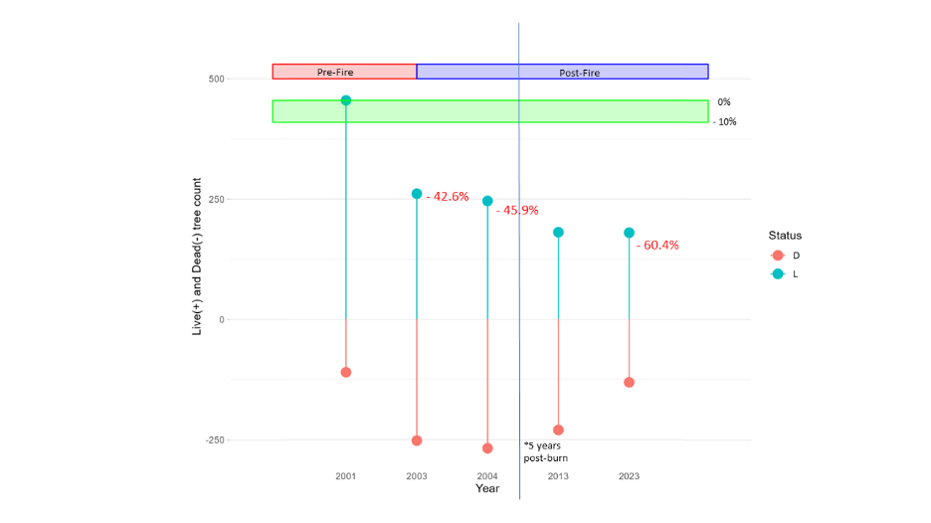

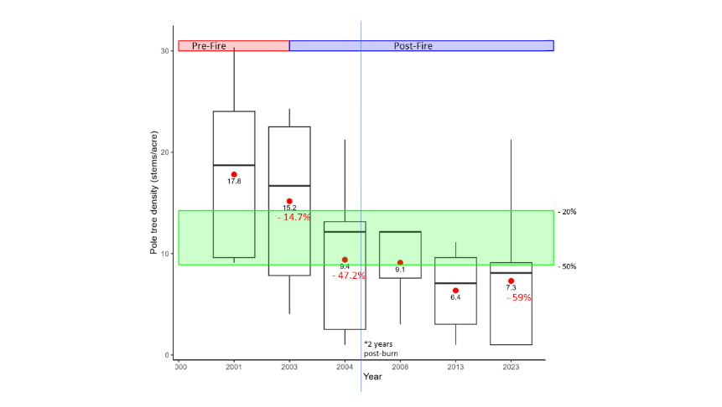

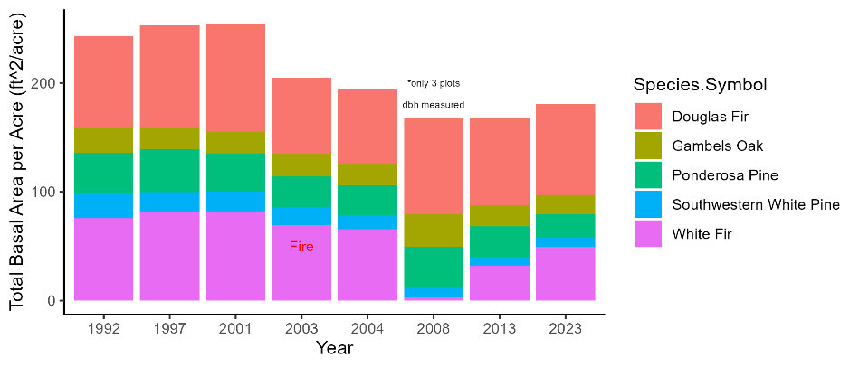

**Cover Protocol Data Utility**

## **Canopy Cover**

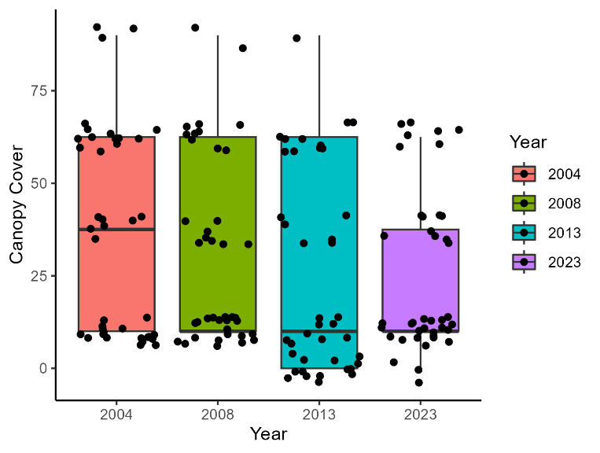Starting in 2004, Saguaro fire effects began collecting data with a new protocol, labeled Cover – Species Composition (metric) in FFI. The data collected included an estimation of canopy cover in each quarter of the forest plot, using five categories: 0 (0%), 1 (1-20%), 2 (21 - 50%), 3 (51 - 80%), or 4 (81-100%). These classes were recorded as range midpoints in FFI, with the following values: 0%, 10%, 37.5%, 62.5%, or 100% canopy cover.

In the Spring of 2024, we evaluated these data and found little potential utility. We found no significant difference in canopy cover between years (Figure 4). Canopy covers were compared to the most common herbaceous species identified in plots and proportions of grasses and forbs recorded in plots. No significant trends over time or correlations between canopy cover and species composition were found (Figure 7).

Figure 4. Canopy cover from 2004 - 2023. No significant difference was found between years (p=0.14)

Figure 5. Canopy cover compared to total basal area per acre

Canopy cover was plotted against total basal area per acre for each corresponding plot and year and we ran a linear model to determine the relationship between the variables. There was a significant relationship between these two variables (r-squared adjusted= 0.6136, p= 3.072e-07). While it was good to see that the expected relationship between canopy cover and basal area was held true with these protocols (and was statistically significant), there seems to be little utility in collecting canopy cover classes when trees are being measured for dbh. Additionally, live crown base height could be a valuable measurement for similar management questions if we continue to collect it for each tree, as was done in 2023.

## **Most Common Herbaceous Species**

In 2008 under the Cover – Species Composition protocol, Saguaro fire effects staff began recording the three most common species found in each forest plot. We have several concerns about the quality and utility of these observations. First, fire effects crews are rarely trained in botany and often lack proper plant identification skills, therefore the accuracy of this data is in question. In many instances, the plants were not identified to species, but recorded as “unknown forb” or “unknown grass”. Second, many plots are simply missing observations,presumably due to a lack of confidence in plant identification or forgetting to complete the protocol. Third, the vegetation crew at SODN have already collected high-quality vegetation data from Mica Mountain and have published their results (Appendix CITE VEG INVENTORY). Their findings are a more reliable sources for describing the common species in these natural communities.

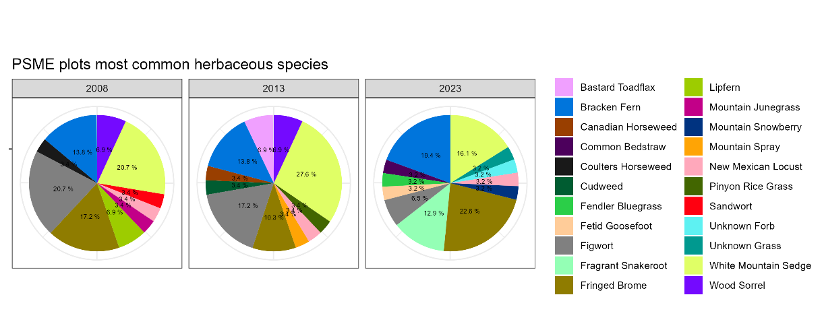

Figure 6. Most common herbaceous species (common names) recorded from 2008 to 2023.

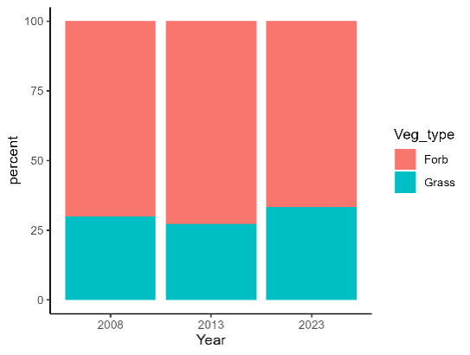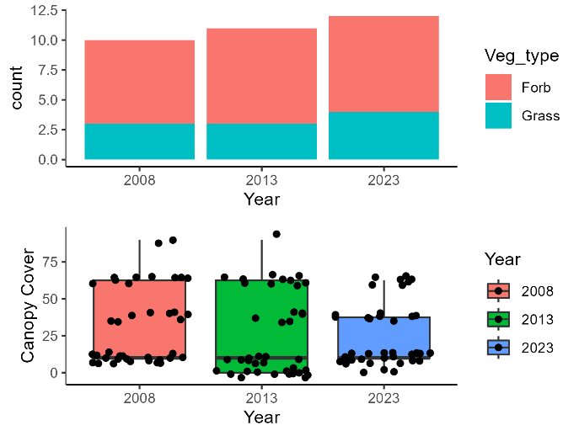

Figure 7. Percentage of grasses recorded to forbs recorded in most common herbaceous species data in Douglas fir plots. No significant difference between years (p= ADD RESULT)

Figure 8. Canopy cover data compared to count data of grasses and forbs in Douglas Fir plots. No significant correlation found (p=0.86)

We investigated the utility of this protocol by looking at changes in species composition over time (Figure 6), proportions of grasses and forbs over time, (Figure 7), and correlations between species composition and canopy cover (Figure 8). There was no significant difference in the proportion of graminoids vs. forbs between years and no significant correlation with canopy cover. After examining the results, we did not find any trends worth noting. This brings into question the reliability and utility of this metric.

## **Additional Species**

In addition to the three most common herbaceous species, crews had the option to record any additional species of note. No data was collected for additional species in 2004. Figure 9 shows a count of how many species were recorded from 2008 – 2023. Many additional species were recorded in 2008 and few were recorded in subsequent years. We have the same concerns with this data as the most common herbaceous species data, as well as its inconsistency over time.

Figure 9. Count of additional species recorded per plot from 2008 - 2023 for Douglas Fir plots

## **Invasive Species**

During the four years this protocol has been in use, there have only been two instances when an invasive species was recorded: *Trifolium pinetorum* in PSME-03 (2023), and Bromus rubens in PSME-08 (2013), which was subsequently pulled.

## **Overall Recommendations**

1. Discontinue current herbaceous species protocol
   1. Instead – collaborate with SODN vegetation monitoring crew and use data collected for Saguaro vegetation inventory.
   2. Brainstorm options for a more useful herbaceous data protocol.
2. Discontinue canopy cover protocol
   1. Instead – continue collecting live crown base height data for individual trees
3. Train fire effects crews to recognize, report, and treat local invasive species of concern appropriately when encountered, and include a note in the comments section of the plot data.